從<https://archive.ics.uci.edu/ml/datasets/Poker+Hand>下載dataset

**Attribute Information:**

1) S1 "Suit of card #1"  
Ordinal (1-4) representing {Hearts, Spades, Diamonds, Clubs}  
  
2) C1 "Rank of card #1"  
Numerical (1-13) representing (Ace, 2, 3, ... , Queen, King)  
  
3) S2 "Suit of card #2"  
Ordinal (1-4) representing {Hearts, Spades, Diamonds, Clubs}  
  
4) C2 "Rank of card #2"  
Numerical (1-13) representing (Ace, 2, 3, ... , Queen, King)  
  
5) S3 "Suit of card #3"  
Ordinal (1-4) representing {Hearts, Spades, Diamonds, Clubs}  
  
6) C3 "Rank of card #3"  
Numerical (1-13) representing (Ace, 2, 3, ... , Queen, King)  
  
7) S4 "Suit of card #4"  
Ordinal (1-4) representing {Hearts, Spades, Diamonds, Clubs}  
  
8) C4 "Rank of card #4"  
Numerical (1-13) representing (Ace, 2, 3, ... , Queen, King)  
  
9) S5 "Suit of card #5"  
Ordinal (1-4) representing {Hearts, Spades, Diamonds, Clubs}  
  
10) C5 "Rank of card 5"  
Numerical (1-13) representing (Ace, 2, 3, ... , Queen, King)  
  
11) CLASS "Poker Hand"  
Ordinal (0-9)  
  
0: Nothing in hand; not a recognized poker hand  
1: One pair; one pair of equal ranks within five cards  
2: Two pairs; two pairs of equal ranks within five cards  
3: Three of a kind; three equal ranks within five cards  
4: Straight; five cards, sequentially ranked with no gaps  
5: Flush; five cards with the same suit  
6: Full house; pair + different rank three of a kind  
7: Four of a kind; four equal ranks within five cards  
8: Straight flush; straight + flush  
9: Royal flush; {Ace, King, Queen, Jack, Ten} + flush

程式碼

data=csvread('poker.csv');

predictor=data(:,1:10)';

response=data(:,11)';

R=zeros(3,25010);%共25010筆資料，分三類

R(1,response <=3)=1;

R(2,response >=4 & response <=6)=1;

R(3,response >=7)=1;

Training data

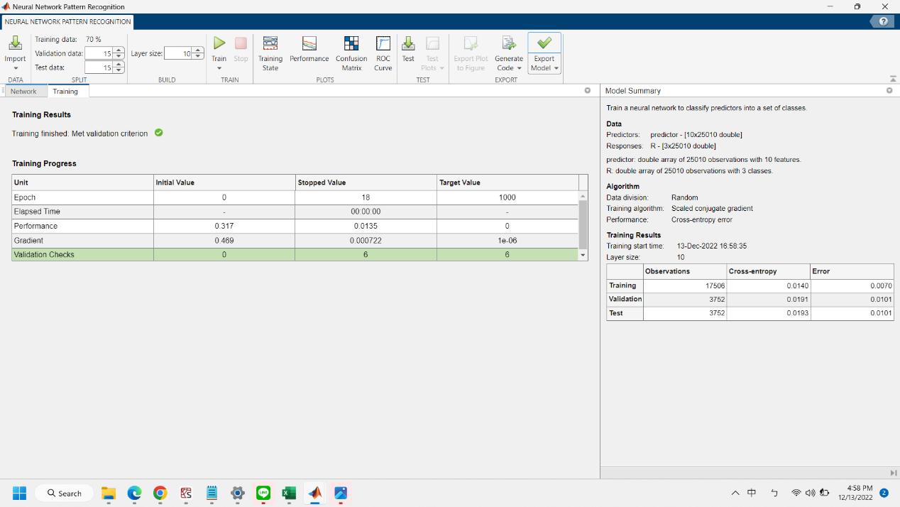

Training data的錯誤率為0.0070

Validation的錯誤率為0.0191

Test的錯誤率為0.0193

Confusion matrix

